 |  | TABLE OF CONTENTS
TOPICS |  |  | Page no.
I. Title Page |  | 1
II. Table of Content |  | 2
1. | Introduction and Scenario | 3
2. | ER Diagram | 4
3. | Normalization | 5-10
4. | Schema Design | 11
5. | Table Creation | 12-15
6. | Value Insertion | 16-21
7. | Required Queries | 22-27
8. | Conclusion | 28

Introduction

Our project, known as the "Port Management System," is a comprehensive solution for overseeing all operations and activities at a shipping seaport. With the use of Oracle, we can manage data effectively, prevent security breaches, and grant access to the application. Our objective is to provide port operators with an efficient and user-friendly platform that can assist them in their duties, such as cargo handling, vessel tracking, berth scheduling, and more. Our system includes useful features to simplify workflows and enhance operational efficiency. Whether it's monitoring real-time vessel arrivals and departures or managing inventory levels of cargo, the Port Management System offers a centralized platform for accessing, analyzing, and managing critical data. Our project caters to the needs of port operators, stakeholders, and customers by leveraging the power of data analytics and visualization tools to optimize resource allocation and improve overall performance. We are confident that our Port Management System will revolutionize the shipping industry, and we are eager to introduce it to the market.

Scenario

The Port Management System is designed to manage the operations of a port. It stores information about the different entities involved in the port operations such as port, employees, shipping agencies, delivery men, vehicles, storage areas, payment system, platform, ship, and container. Port has its own name, port ID and port location. The system then creates a unique identifier for the port and stores this information in the database. When an employee is hired to work for the port, their name, ID, designation, salary, and phone number are entered into the system. The system also records the port they work for. This information is used to generate employee records that can be used to manage their work schedules, salaries, and other related functions. When a new shipping agency is added to the system, the agency ID and agency name are entered into the system. This information is used to manage the shipping agencies that are operating at the port. When a delivery man is hired by a shipping agency, their ID, name, and delivery car details are entered into the system. The system records the shipping agency they work for and uses this information to manage their work schedules. When a vehicle arrives at the port, its vehicle number and type are entered into the system. This information is used to manage the parking and traffic flow within the port. When a new storage area is added to the port, its location and area number are entered into the system. This information is used to manage the storage of goods within the port. When a payment is made for services rendered at the port, the payment ID and payment type (online or offline) are entered into the system. This information is used to manage the accounting functions of the port. When a new platform is added to the port, its platform number is entered into the system. This information is used to manage the docking and undocking of ships. When a ship arrives at the port, its ship name, captain name, ship ID, arriving place and destination place are entered into the system. The system then creates a unique identifier for the ship and stores this information in the database. When containers are loaded or unloaded from a ship, their container number, origin, owner and destination are entered into the system. This information is used to manage the logistics and tracking of the containers within the port. Overall, the Port Management System provides a comprehensive platform for managing the different entities and operations within a port, allowing for efficient and effective port management.

ER Diagram

3 | P a g e
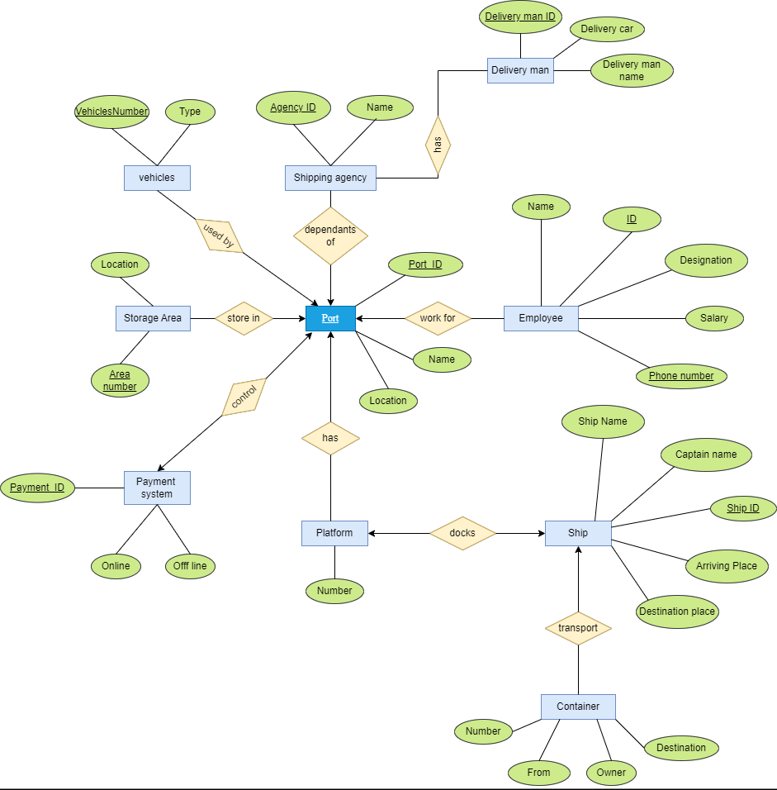

Normalization

4 | P a g e
Employee work for Port:
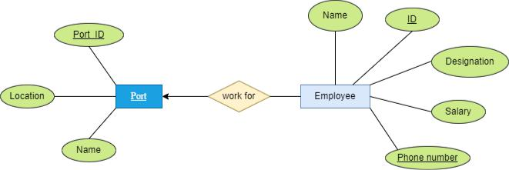

UNF: e_name , e_Id, designation, salary , phone_number, port_name , port_location , port_ Id

1NF: 1st: e_name , e_Id, designation, salary , phone_number, Name , port_location , port_ Id

(Phone_Number is Multivalued)

2NF: 1st: e_name, e_Id, designation, salary, phone_number, port_id

2nd: port_name, port_ Id, port_location

3NF: 1st: e_name, e_Id, designation, salary, phone_number, port_id

2nd: port_name, port_ Id, port_location

Port depends on Shipping Agency:
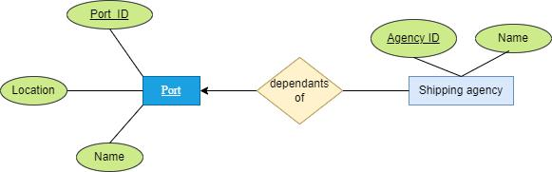

UNF: agency id, agency_name, port_name, port_location, port_id

1NF: 1st: agency id, port_name , port_location , port_ id

(No multivalue)

2NF: 1st: agency id, agency_name, port_id

2nd: port_name, port_ id, port_location

5 | P a g e
3NF: 1st: agency id, agency_name, port_id

2nd: port_name, port_ id, port_location

Shipping Agency Has Delivery Man:
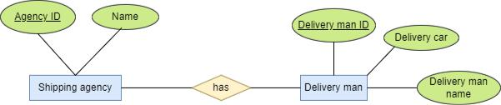

UNF: agency_id, agency_name, dMan_name, dMan_id, dCar

1NF: agency_id, agency_name, dMan_name, dMan_id, dCar

(No multivalue)

2NF: 1st: agency id, agency_name

2nd: dMan_name, dMan_id, dCar, agency_id

3NF: 1st: agency id, agency_name, dMan_id

2nd: dMan_name, dMan_id, dCar, agency_id

Vehicle used by port:
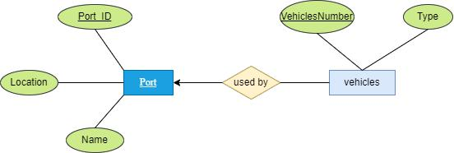

UNF: vehicle_type , vehicle_number , port_name, port_ Id, port_location

1NF : 1st: vehicle_type , vehicle_number , port_name, port_ Id, port_location

(No multivalued)

2NF: 1st: vehicle_type , vehicle_number , port_id

2nd: port_name, port_ Id, port_location

6 | P a g e
3NF: 1st: vehicle_type , vehicle_number , port_id

2nd: port_name, port_ Id, port_location

Port store in Storage_Area :
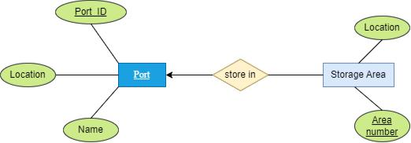

UNF: area_number ,storage_location, port_name, port_ Id, port_location

(No multivalue)

1NF : 1st: area_number ,storage_location, port_name, port_ Id, port_location

2NF: 1st: area_number ,storage_location, port_ Id

2nd: port_name, port_ Id, port_location

3NF: 1st: area_number ,storage_location, port_ Id

2nd: port_name, port_ Id, port_location

Port control Payment_ System:
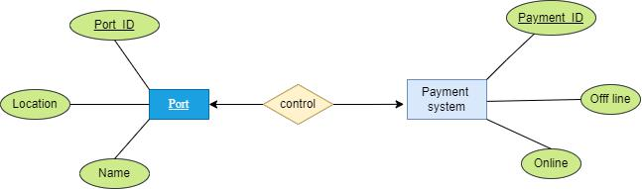

UNF: payment_id, online, offline, port_name, port_ Id , port_location

1NF : 1st: payment_id, online, offline, port_name, port_ Id , port_location

(No multivalue)

7 | P a g e

2NF: 1st: payment_id, online, offline, port_id

2nd: port_name, port_ Id , port_location

3NF: 1st: payment_id, online, offline, port_id

2nd: port_name, port_ Id , port_location

Port Has Platform:
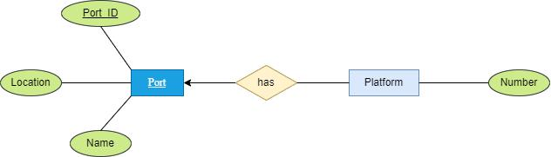

UNF: platform_ number, port_name, port_ Id , port_location

1NF : 1st: platform_ number, port_name, port_ Id , port_location

(No multivalue)

2NF: 1st: platform number, port_id

2nd: port_name, port_ Id , port_location

3NF: 1st: platform number, port_id

2nd: port_name, port_ Id , port_location

Platform Docks Ship:

8 | P a g e
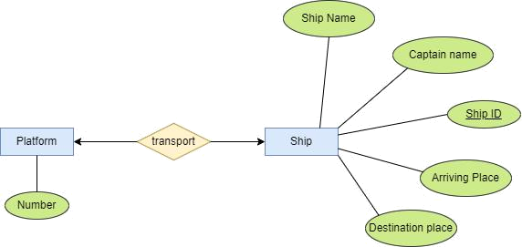

UNF: platform_ number, ship_ id, ship_ name, captain_ name , arriving_ place, destination_ place

1NF : 1st: platform_ number, ship_ id, ship_ name, captain_ name , arriving_ place, destination_ place

(No multivalue)

2NF: 1st: platform_number

2nd: ship_ id, ship_ name, captain_ name , arriving_ place, destination_ place, platform_number

3NF: 1st: platform_number

2nd: ship_ id, ship_ name, captain_ name , arriving_ place, destination_ place, platform_number

Ship Transport Container:
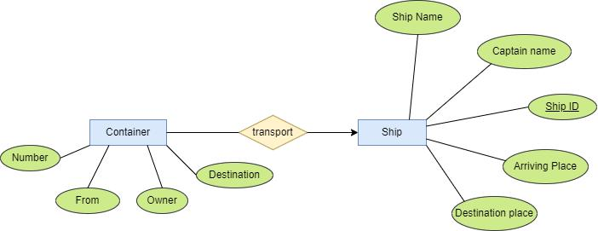

UNF: ship_id, ship_name, captain_name, arriving_ place, destination_ place, container_ number, Owner, container_ from, container_ destination.

1NF : 1st ship_id, ship_name, captain_name, arriving_ place, destination_ place, container_ number, Owner, container_ from, container_ destination.

(No multivalue)

2NF: 1st: ship_id, ship_name, captain_name, arriving_ place, destination_ place

2nd: container_ number, Owner, container_ from, container_ destination, ship_id
9 | P a g e
3NF: 1st: ship_id, ship_name, captain_name, arriving_ place, destination_ place

2nd: container_ number, Owner, container_ from, container_ destination, ship_id

Temporary Table:

- e_name, e_Id, designation, salary, phone_number, port_id

- port_name, port_ Id, port_location

- agency id, agency_name, port_id

- port_name, port_ id, port_location

- agency id, agency_name

- dMan_name, dMan_id, dCar, agency_id

- vehicle_type , vehicle_number , port_id

- port_name, port_ Id, port_location

- area_number ,storage_location, port_ Id

- port_name, port_ Id, port_location

- payment_id, online, offline, port_id

- port_name, port_ Id , port_location

- platform number, port_id

- port_name, port_ Id , port_location

- platform_number

- ship_ id, ship_ name, captain_ name , arriving_ place, destination_ place, platform_number

- ship_id, ship_name, captain_name, arriving_ place, destination_ place

- container_ number, Owner, container_ from, container_ destination, ship_id

Final Table:

- e_name, e_Id, designation, salary, phone_number, port_id

- port_name, port_ Id, port_location

- agency id, agency_name, port_id

- dMan_name, dMan_id, dCar, agency_id

- vehicle_type , vehicle_number , port_id

- area_number ,storage_location, port_ Id

- payment_id, online, offline, port_id

- platform number, port_id

- ship_ id, ship_ name, captain_ name , arriving_ place, destination_ place, platform_number

- container_ number, Owner, container_ from, container_ destination, ship_id

Schema Design

10 | P a g e
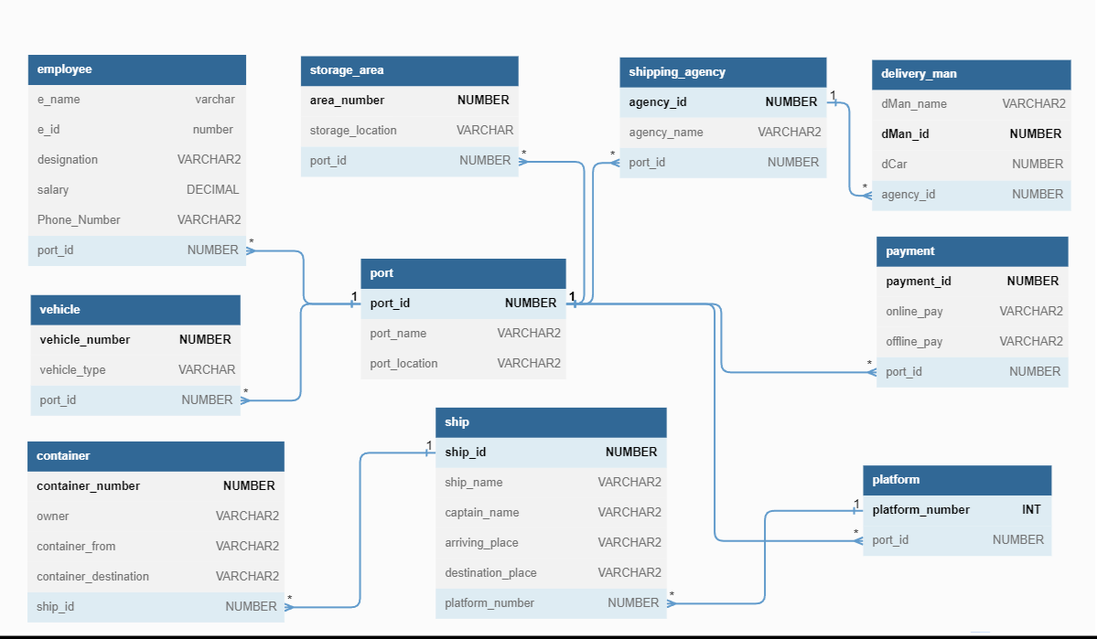

Table Creation

11 | P a g e
1. CREATE TABLE port (

port_id NUMBER PRIMARY KEY,

port_name VARCHAR2(50),

port_location VARCHAR2(30)

);
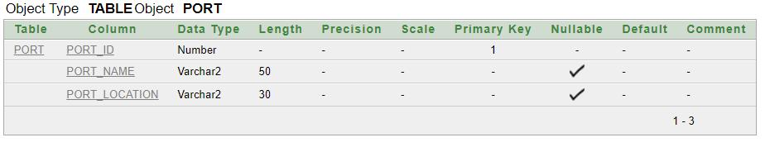

- CREATE TABLE employee ( e_name VARCHAR2(30),

e_id NUMBER PRIMARY KEY, designation VARCHAR2(20), salary DECIMAL(10,2), Phone_Number VARCHAR2(15),
port_id NUMBER,

FOREIGN KEY (port_id) REFERENCES port(port_id)

);
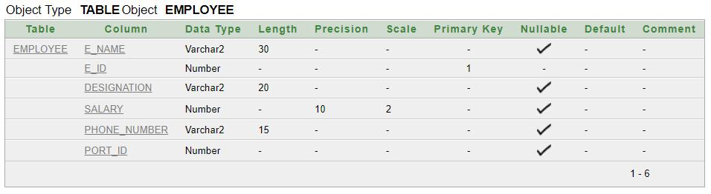

- CREATE TABLE shipping_agency( agency_id NUMBER PRIMARY KEY, agency_name VARCHAR2(30), port_id NUMBER,
FOREIGN KEY(port_id) REFERENCES port(port_id)

);
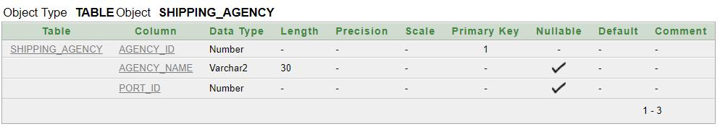

12 | P a g e

- CREATE TABLE delivery_man ( dMan_name VARCHAR2(20), dMan_id NUMBER PRIMARY KEY, dCar NUMBER,

agency_id NUMBER,

FOREIGN KEY(agency_id) REFERENCES shipping_agency(agency_id)

);
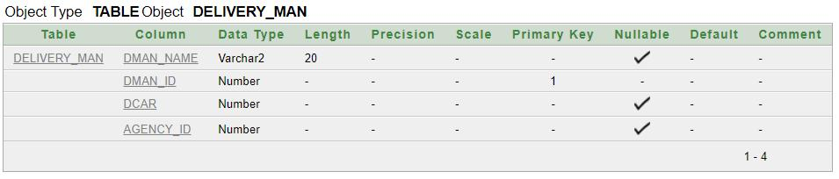

5. CREATE TABLE vehicle(

vehicle_number NUMBER PRIMARY KEY,

vehicle_type VARCHAR(10),

port_id NUMBER,

FOREIGN KEY (port_id) REFERENCES port(port_id)

);
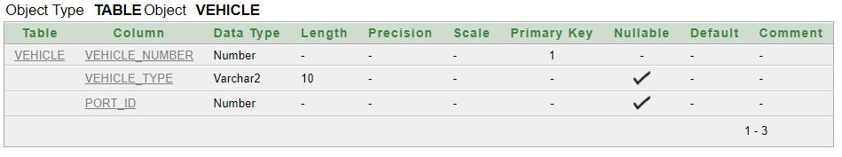

6. CREATE TABLE storage_area(

area_number NUMBER PRIMARY KEY,

storage_location VARCHAR(5),

port_id NUMBER,

FOREIGN KEY(port_id) REFERENCES port(port_id)

);
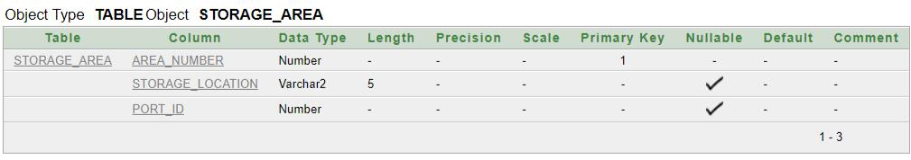

7. CREATE TABLE payment(

payment_id NUMBER PRIMARY KEY,

online_pay VARCHAR2(3),

13 | P a g e
offline_pay VARCHAR2(3),

port_id NUMBER,

FOREIGN KEY(port_id) REFERENCES port(port_id)

);
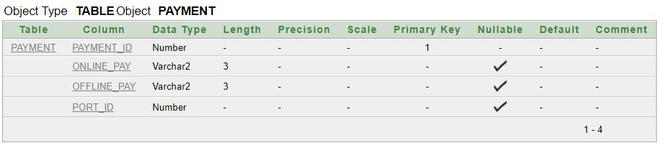

8. CREATE TABLE platform(

platform_number INT PRIMARY KEY,

port_id NUMBER,

FOREIGN KEY (port_id) REFERENCES port(port_id)

);
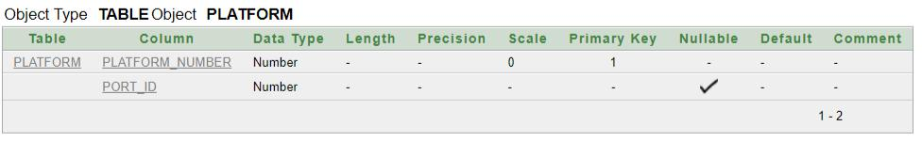

9. CREATE TABLE ship(

ship_id NUMBER PRIMARY KEY,

ship_name VARCHAR2(20),

captain_name VARCHAR2(20),

arriving_place VARCHAR2(10),

destination_place VARCHAR2(10),

platform_number NUMBER,

FOREIGN KEY (platform_number) REFERENCES platform(platform_number) );

14 | P a g e
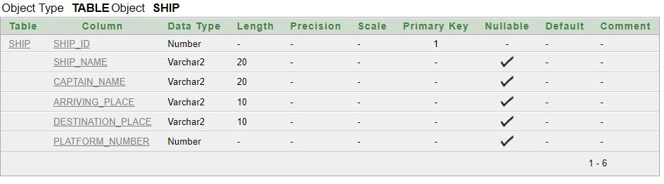

10. CREATE TABLE container(

container_number NUMBER PRIMARY KEY,

owner VARCHAR2(20),

container_from VARCHAR2(20),

container_destination VARCHAR2(20),

ship_id NUMBER,

FOREIGN KEY (ship_id) REFERENCES ship(ship_id)

);
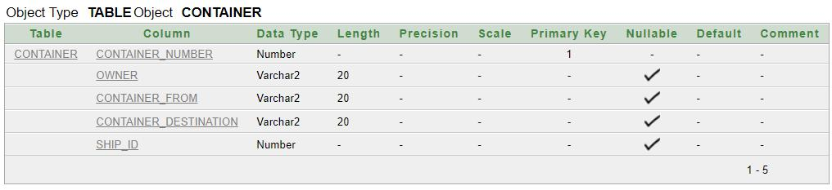

15 | P a g e
Value Insertion

- Port:

INSERT INTO port VALUES(11001, 'CHITTAGONG PORT', 'CHITTAGONG'); INSERT INTO port VALUES(11002, 'COXS BAZAR PORT', 'COXS BAZAR'); INSERT INTO port VALUES(11003, 'KUAKATA PORT', 'KUAKATA'); INSERT INTO port VALUES(11004, 'CHANDPUR PORT', 'CHANDPUR'); INSERT INTO port VALUES(11005, 'GAIBANDHA PORT', 'GAIBANDHA');
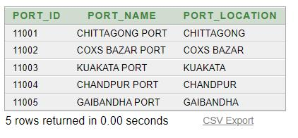

- Employee

INSERT INTO employee VALUES('Akif', 2000, 'Manager', 35000, '01314151610', 11001); INSERT INTO employee VALUES('John Doe', 5010, 'Manager', 50000, '5555555555', 11003); INSERT INTO employee VALUES('Jane Smith', 5011, 'Salesperson', 40000, '5551234567', 11003);

INSERT INTO employee VALUES('Bob Johnson', 5012, 'Accountant', 45000, '5559876543', 11003);

INSERT INTO employee VALUES('Sarah Lee', 6013, 'HR Specialist', 35000, '5555551212', 11004);

INSERT INTO employee VALUES('Mark Brown', 6014, 'Marketing Manager', 55000, '5551112222', 11004);

INSERT INTO employee VALUES('Lisa Davis', 6015, 'Customer Service Rep', 32000, '5558887777', 11004);

INSERT INTO employee VALUES('Mike Johnson', 7016, 'IT Support', 38000, '554554555', 11005);

INSERT INTO employee VALUES('Karen Martinez', 7017, 'Operations Manager', 52000, '5553334444', 11005);

INSERT INTO employee VALUES('Tom Thompson', 7018, 'Designer', 42000, '5555551212', 11005);

INSERT INTO employee VALUES('Anna Rodriguez', 7019, 'Developer', 48000, '5557778888', 11005);

INSERT INTO employee VALUES('Johir', 1009, 'Clerk', 30000, '01314151602', 11003); INSERT INTO employee VALUES('Nion', 1006, 'Asst. Manager', 30000, '01314151605', 11003);

INSERT INTO employee VALUES('Adanan', 1004, 'Manager', 40000, '01314151603', 11003); INSERT INTO employee VALUES('Jidan', 3003, 'Manager', 33000, '01314151619', 11002); INSERT INTO employee VALUES('Salam', 3000, 'Driver', 13000, '01314151618', 11001); INSERT INTO employee VALUES('Kalam', 2004, 'Driver', 12000, '01314151612', 11001); INSERT INTO employee VALUES('Hasib', 2001, 'Asst. Manager', 25000, '01314151611', 11001);

16 | P a g e
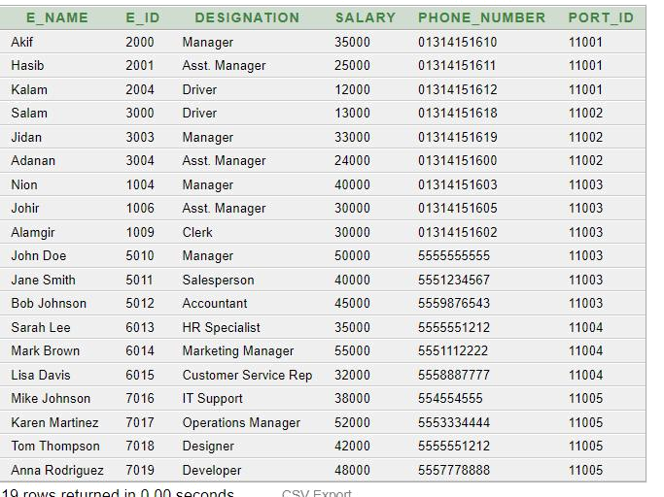

- Shipping_agency:

INSERT INTO shipping_agency VALUES(1001, 'Lockwood And Co.', 11001); INSERT INTO shipping_agency VALUES(1002, 'Midas Shipping', 11002); INSERT INTO shipping_agency VALUES(1003, 'Global Shipping Lines', 11003); INSERT INTO shipping_agency VALUES(1004, 'Express Shipping Co.', 11004); INSERT INTO shipping_agency VALUES(1005, 'Pacific Ocean Shipping', 11005);
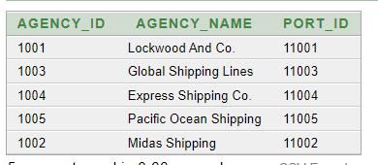

- Delivery_man

INSERT INTO delivery_man VALUES('Alif', 3301, 999444, 1001); INSERT INTO delivery_man VALUES('Bob', 3302, 888555, 1002); INSERT INTO delivery_man VALUES('Charlie', 3303, 777666, 1003); INSERT INTO delivery_man VALUES('David', 3304, 666777, 1004); INSERT INTO delivery_man VALUES('Frank', 3305, 444999, 1005);

17 | P a g e
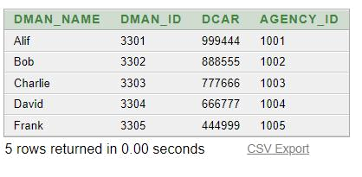

- Vehicle

INSERT INTO vehicle VALUES(6699880, 'Crane', 11001); INSERT INTO vehicle VALUES(6699881, 'Forklift', 11001); INSERT INTO vehicle VALUES(6699882, 'Bulldozer', 11002); INSERT INTO vehicle VALUES(6699883, 'Dump Truck', 11002); INSERT INTO vehicle VALUES(6699884, 'Excavator', 11004); INSERT INTO vehicle VALUES(6699885, 'Loader', 11003); INSERT INTO vehicle VALUES(6699886, 'Tractor', 11003); INSERT INTO vehicle VALUES(6699887, 'Backhoe', 11004); INSERT INTO vehicle VALUES(6699888, 'Skid Steer', 11005); INSERT INTO vehicle VALUES(6699889, 'Crane Truck', 11005);
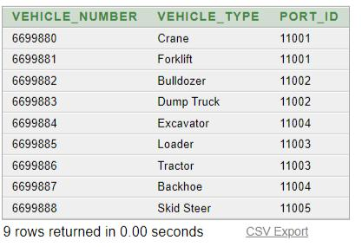

- Storage_area

INSERT INTO storage_area VALUES(1, 'South', 11001); INSERT INTO storage_area VALUES(2, 'North', 11002); INSERT INTO storage_area VALUES(3, 'East', 11003); INSERT INTO storage_area VALUES(4, 'West', 11005); INSERT INTO storage_area VALUES(5, 'Mid', 11001);
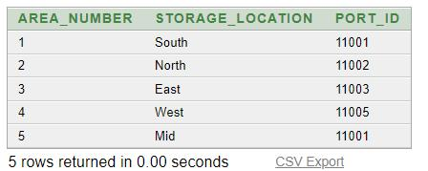

18 | P a g e
- Payment

INSERT INTO payment VALUES(2233,'yes', '',11001); INSERT INTO payment VALUES(2333,'', 'No',11001); INSERT INTO payment VALUES(1111, 'yes', NULL, 11002); INSERT INTO payment VALUES(2222, NULL, 'No', 11002); INSERT INTO payment VALUES(3333, 'yes', NULL, 11003); INSERT INTO payment VALUES(4444, NULL, 'No', 11003); INSERT INTO payment VALUES(5555, 'yes', NULL, 11004); INSERT INTO payment VALUES(6666, NULL, 'No', 11004); INSERT INTO payment VALUES(7777, 'yes', NULL, 11005); INSERT INTO payment VALUES(8888, NULL, 'No', 11005); INSERT INTO payment VALUES(9999, 'yes', NULL, 11003);
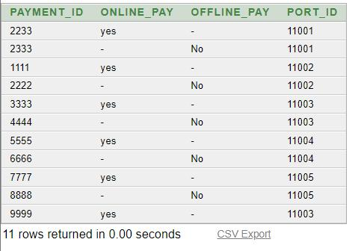

- Platform

INSERT INTO platform VALUES(101, 11001); INSERT INTO platform VALUES(102, 11001); INSERT INTO platform VALUES(103, 11001); INSERT INTO platform VALUES(104, 11001); INSERT INTO platform VALUES(201, 11002); INSERT INTO platform VALUES(202, 11002); INSERT INTO platform VALUES(203, 11002); INSERT INTO platform VALUES(204, 11002); INSERT INTO platform VALUES(302, 11003); INSERT INTO platform VALUES(301, 11003); INSERT INTO platform VALUES(303, 11003); INSERT INTO platform VALUES(304, 11003); INSERT INTO platform VALUES(401, 11004); INSERT INTO platform VALUES(402, 11004); INSERT INTO platform VALUES(403, 11004); INSERT INTO platform VALUES(404, 11004); INSERT INTO platform VALUES(501, 11005); INSERT INTO platform VALUES(502, 11005); INSERT INTO platform VALUES(503, 11005); INSERT INTO platform VALUES(504, 11005);

19 | P a g e
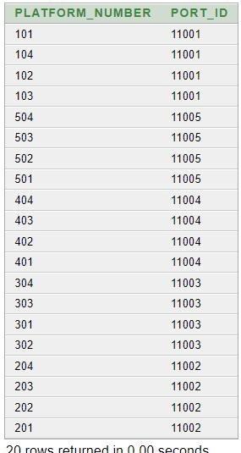

- Ship

INSERT INTO ship VALUES(66009, 'HMS Kashmir', 'Harrison', 'Nepal', 'India', 101); INSERT INTO ship VALUES(62007, 'HMS Lukaku', 'Jhon', 'India', 'Srilanka', 102); INSERT INTO ship VALUES(58007, 'HMS Onana', 'Kimmich', 'India', 'Newzeland', 203); INSERT INTO ship VALUES(98707, 'HMS Promitheus', 'O Khan', 'Bhutan', 'Nigeria', 302); INSERT INTO ship VALUES(44765, 'HMS Posaidon', 'Nirjan', 'Russia', 'Finland', 304); INSERT INTO ship VALUES(47365, 'HMS Kraken', 'Miller', 'Australia', 'Finland', 404); INSERT INTO ship VALUES(47985, 'HMS Tormada', 'Vini', 'Australia', 'Netherland', 401); INSERT INTO ship VALUES(10101, 'JackDaw', 'Edward', 'Bangladesh', 'Russia', 503); INSERT INTO ship VALUES(99999, 'Black Pearl', 'Jack', 'Bangladesh', 'Thailand', 502);
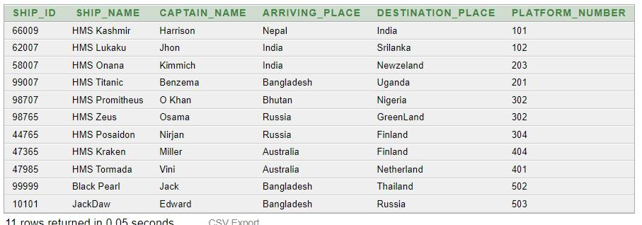

10. Container

20 | P a g e

INSERT INTO container VALUES(67, 'Dre Parker', 'California', 'Tokyo',66009); INSERT INTO container VALUES(68, 'Miyagi', 'Hokkaido', 'Los Angeles',66009); INSERT INTO container VALUES(69, 'Daniel LaRusso', 'New Jersey', 'Beijing',66009); INSERT INTO container VALUES(70, 'Johnny Lawrence', 'California', 'Sydney',62007); INSERT INTO container VALUES(71, 'Ali Mills', 'California', 'London',62007); INSERT INTO container VALUES(72, 'Chozen Toguchi', 'Okinawa', 'Paris',62007); INSERT INTO container VALUES(73, 'Jessica Andrews', 'Georgia', 'Shanghai',58007); INSERT INTO container VALUES(74, 'Terry Silver', 'California', 'Dubai',58007); INSERT INTO container VALUES(75, 'Mike Barnes', 'Arizona', 'Moscow',99007); INSERT INTO container VALUES(76, 'Julie Pierce', 'California', 'Rio de Janeiro',10101); INSERT INTO container VALUES(77, 'Dutch', 'New York', 'Seoul',99007);
INSERT INTO container VALUES(78, 'Bobby Brown', 'Texas', 'Berlin',98707);

INSERT INTO container VALUES(79, 'Tommy', 'California', 'Mumbai',98707);

INSERT INTO container VALUES(80, 'John Kreese', 'California', 'Bangkok',98707);

INSERT INTO container VALUES(81, 'Sato Toguchi', 'Okinawa', 'New York',99999);

INSERT INTO container VALUES(82, 'Yukie', 'Okinawa', 'Miami',98765);

INSERT INTO container VALUES(83, 'Kumiko', 'Okinawa', 'Toronto',98765);

INSERT INTO container VALUES(84, 'Tory Nichols', 'California', 'Hong Kong',44765);

INSERT INTO container VALUES(85, 'Robbie Keene', 'California', 'Madrid',47365);

INSERT INTO container VALUES(86, 'Samatha LaRusso', 'California', 'Buenos Aires',47985);
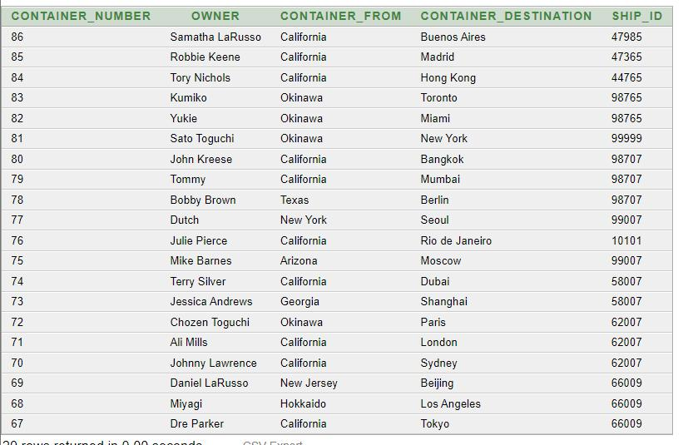

Required Queries

21 | P a g e

Single Row Queries:

- Write a query to show the employee earning more than 30000. SELECT e_id, e_name, designation, salary

FROM employee WHERE salary>30000;
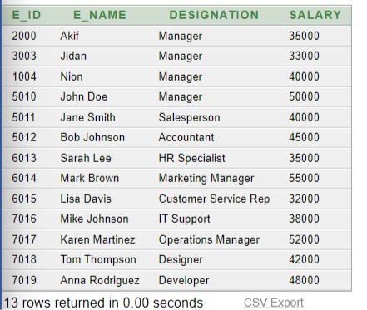

- Write a query to show every employee working in port id 11005. SELECT e_id, e_name, designation, salary, port_id

FROM employee WHERE port_id = 11005;
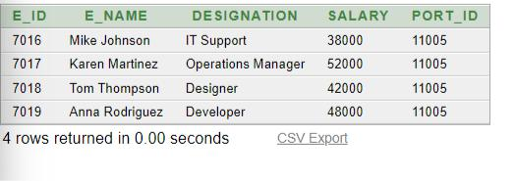

- Write a query to show the ships that are arriving from Bangladesh, India or Russia. SELECT ship_id, ship_name, arriving_place

FROM ship

WHERE arriving_place IN ('Bangladesh', 'India', 'Russia');
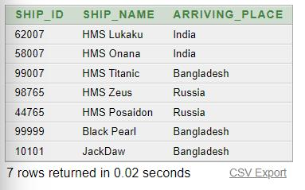

Subquery:

22 | P a g e

- Write a query to show the employees who work in Chittagong port. SELECT e_id, e_name, port_id

FROM employee

WHERE port_id = (Select port_id FROM port WHERE port_name = 'CHITTAGONG PORT');

- Write a query to show the delivery man who works in coxs bazar port. SELECT dMan_name, dMan_id , agency_id

FROM delivery_man WHERE agency_id = (
Select agency_id FROM shipping_agency WHERE port_id = (

Select port_id FROM port WHERE port_name = 'COXS BAZAR PORT'

)

);

- Write a query to show the payment information of kuakata port. SELECT payment_id, online_pay , offline_pay

FROM payment

WHERE port_id = (SELECT port_id FROM port WHERE port_name = 'KUAKATA PORT');
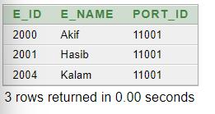
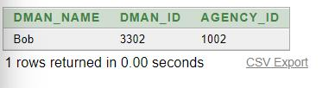
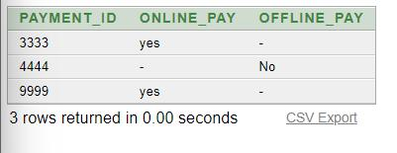

Group Function:

- Find average salery of the employees. SELECT AVG(salary) Average_Salery FROM employee;
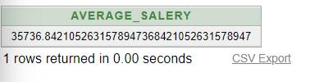

23 | P a g e

- Find maximum salery of the employees. SELECT MAX(salary) Maximum_Salery FROM employee;

- Find minimum salery of the employees in every port. SELECT port_id, MIN(salary) Minimum_Salery FROM employee

GROUP BY port_id;
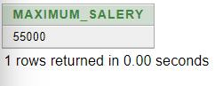
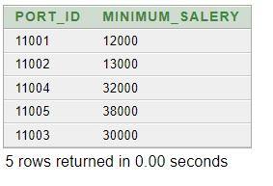

Joining:

- Display the ship information and container information of HMS Prometheus.

SELECT s.ship_id, s.ship_name, c. container_number, c.owner, c.container_destination FROM ship s, container c

WHERE s.ship_name = 'HMS Promitheus' AND s.ship_id = c.ship_id;

- Display the information of platform and ship where HMS Lakuku stayed.

SELECT s.ship_id, s.ship_name, pl.platform_number, po.port_name FROM ship s, platform pl, port po

WHERE s.ship_name = 'HMS Lukaku' AND s.platform_number = pl.platform_number;
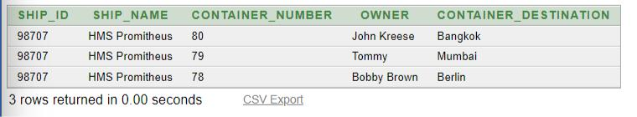

24 | P a g e
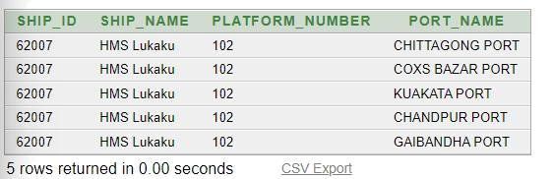

View:

- Create a view for employee id, name and number with salery more than 30000.

CREATE VIEW emp_uv AS

SELECT e_id, e_name, phone_number FROM employee

WHERE salary > 30000;

SELECT * FROM emp_uv;
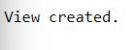
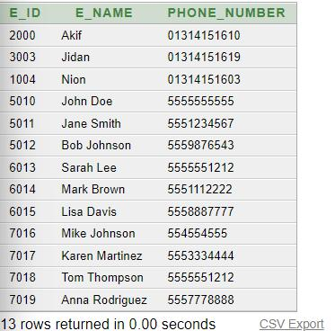

- Create a view for ship name, ship id and destination.

CREATE VIEW ship_vu AS

SELECT ship_id, ship_name, destination_place FROM ship;
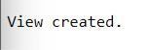

25 | P a g e

SELECT ship_name, destination_place

FROM ship_vu

WHERE ship_id > 70000;
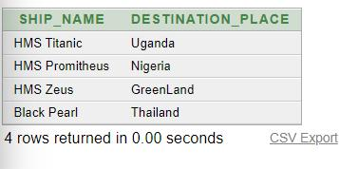

Sequence:

- Create a Sequence for port id, increment by 1 to 11010. CREATE SEQUENCE port_id_sec

START WITH 11000 INCREMENT BY 1 MAXVALUE 11010;

- Show the sequence created earlier.

SELECT sequence_name, max_value, increment_by, last_number FROM user_sequences

WHERE sequence_name = 'PORT_ID_SEC';
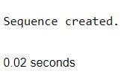
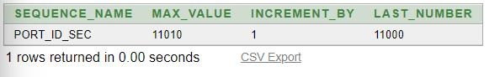

User Creation:

- Create an user.

CREATE USER NISHAT IDENTIFIED BY papabear;

26 | P a g e
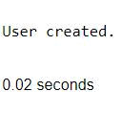

- Create a role named Moderator. CREATE ROLE Moderator;

- Grant create, view and sequence access to Moderator.

GRANT CREATE TABLE, CREATE VIEW, CREATE SEQUENCE TO Moderator;

- Make the user a Moderator. GRANT Moderator TO NISHAT;
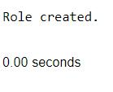
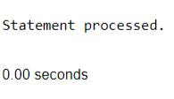
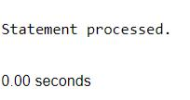

Conclusion

To sum up, the Port Management System is a complex database management system that involves various entities, attributes, and relationships. It is responsible for handling different port-related activities such as managing employees, vehicles, shipping agencies, storage areas, payment systems, and platforms. The database comprises several entities such as port, employee, shipping agency, delivery man, vehicles, storage area, payment system, platform, ship, and container, each with their unique set of attributes. These entities are interrelated through different relationships, which facilitate the management of sea-port activities. All in all, the Port Management System database plays a crucial role in ensuring the efficient operation of ports and optimizing resource utilization.

27 | P a g e

